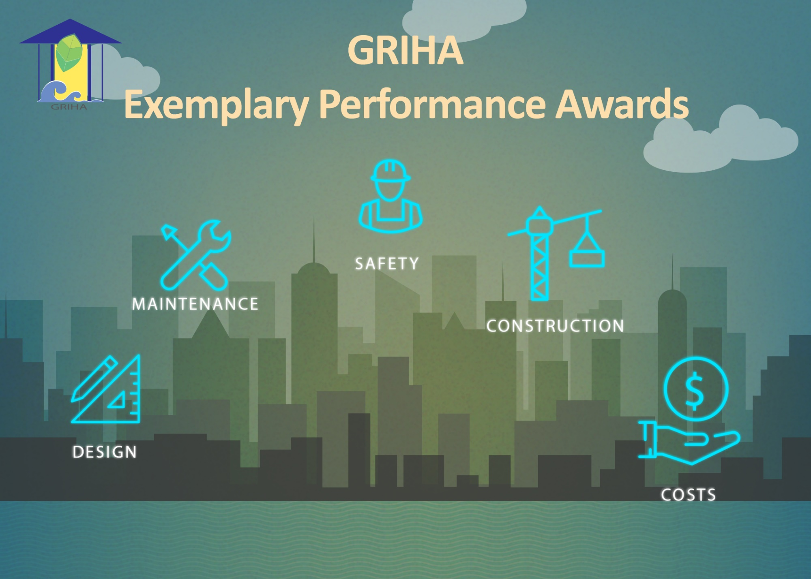

FOR EXISTING BUILDINGS PROJECTS


The presentation should explain project strategies as instructed, supported by photographs, and cover all applicable award categories in a single submission.
Participants must submit the prescribed presentation template provided with the guidelines.
Open application irrespective of any ratings can apply which have embedded sustainable parameters in the project.

Submit entries to ep.awards@grihaindia.org by 10 September 2026.
Winners will be felicitated at the 18th GRIHA Summit on
3rd – 4th November 2026.
Project team may mention their ongoing or completed interventions
Connect on our social media handles for updates
Submit entries to ep.awards@grihaindia.org by 10 September 2026.
Connect on our social media handles for updates

Project Brief
Enter here….

Enter here….

Enter here….

Enter here….

Enter here….
Built-up area (sqm.)

Site area (sqm.)

Location

GRIHA project code

Name of the project
(Please provide Image in JPG format)
Project Brief

No. of building blocks

Enter here….

Year of Completion

Enter here….

Name of building blocks (If blocks are >1)

Enter here….

No. of Storeys

Enter here….

Enter here….

Building typology

(Please provide Image in JPG format)
Waste Management – (20% weightage)
The project team needs to demonstrate that the waste is handled sensibly on site such that the stress on the landfill is reduced.

Waste Management –

- Amount of waste (organic + inorganic) generated ………… kg/capita/day.
- Amount of organic waste (landscape + kitchen) generated ………..kg/capita/day.
- List the key features for waste management strategies.
- Briefly describe measures taken to treat the organic waste generated.

Project Explanation
Final score of the project will be evaluated as per the percentages mentioned below.
Energy Management –
- Ensure that the appliances (fans and internal lighting) installed in the building are minimum BEE 3 star rated
- Demonstrate that …………. % of the total annual energy consumption (consider grid only) is offset through installation of renewable energy sources on site (source, on-site and off-site generation)
- Reduction of energy consumption (%)
- Existing case: ………KWh/year (total annual energy consumption from the grid considering the latest 12-month data (April 2025 to March 2026) with at least 70% occupancy for all the months that have been considered)
- Base case: ……….KWh/year (average of total annual energy consumption from the grid for 2 years prior to the year considered in existing case). Please note that April 2024 to March 2026 will be not be considered.
Note: Projects which have operational data of less than 3 years are required to conduct an energy audit by a BEE certified auditor and submit an energy audit report.

Project Explanation
Final score of the project will be evaluated as per the percentages mentioned below.
Energy Management – (25% weightage)
The project team needs to demonstrate optimization of energy consumption by the use of efficient appliances, use of renewable energy, etc.

Integrated Water Management –
- Briefly describe the water management strategies
- Demand side reduction (%)
- Percentage of water treated …………
- Capacity of STP
- Fresh and treated water consumption per day
- Quantity of treated water generated
Integrated Water Management –
(25% weightage)
The project team needs to demonstrate the water saving, recycling and reuse on site (towards net zero/ net positive approach)

Project Explanation
Final score of the project will be evaluated as per the percentages mentioned below.
Maintenance and Housekeeping–
  - Demonstrate that the refrigerants used in the HVAC system are CFC & HCFC free
  - Demonstrate that the fire fighting systems are halon free
  - Demonstrate that the housekeeping and pest control products used are ecofriendly

Maintenance and Housekeeping –
(20% weightage)
The project team must ensure good practises for maintenance and green procurement as a step towards sustainability.

Project Explanation
Final score of the project will be evaluated as per the percentages mentioned below.
Project Explanation
Final score of the project will be evaluated as per the percentages mentioned below.

Environmental Awareness – (10% weightage)
The project team must submit strategies to promote environmental awareness.

Environmental Awareness-
  - List at-least 2 strategies opted in the project to promote environmental awareness among occupants.

Name | Designation | Organization | Mobile no. | Email id
Contact Details

