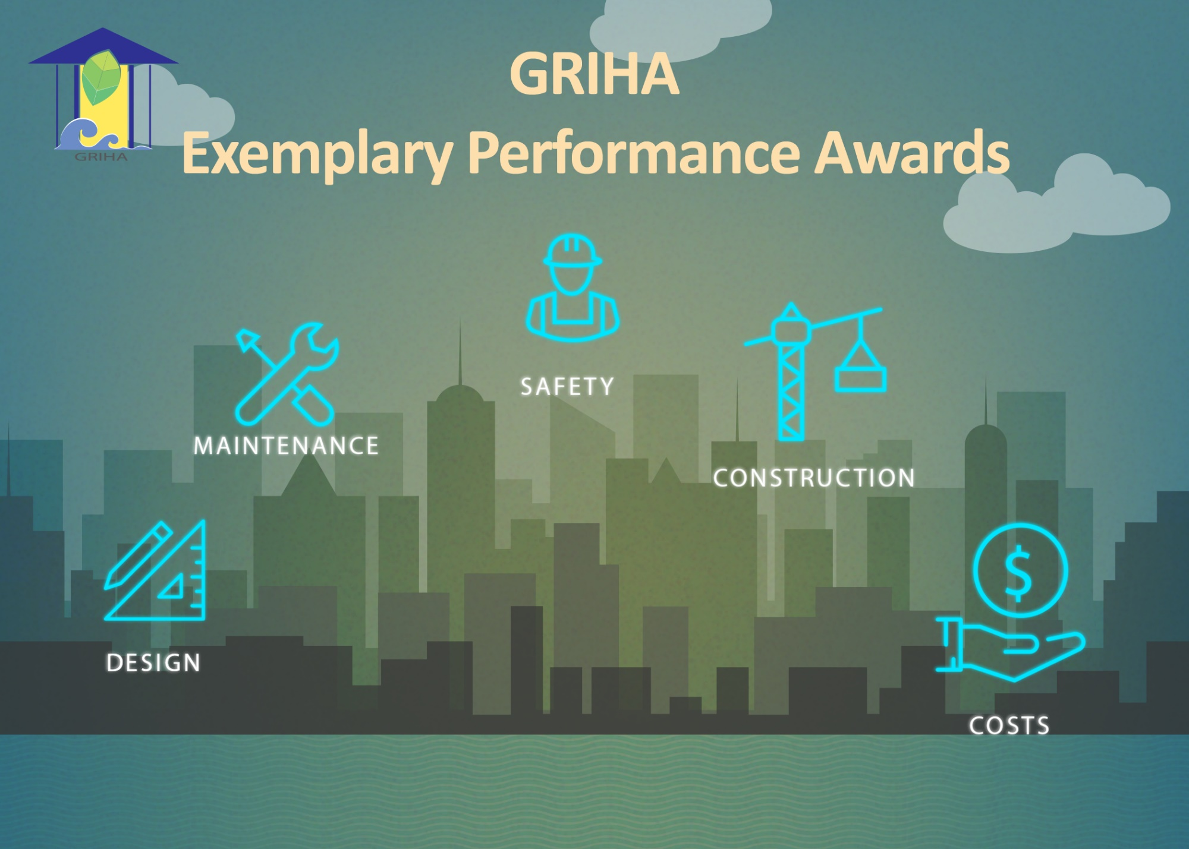

FOR GRIHA REGISTERED PROJECTS

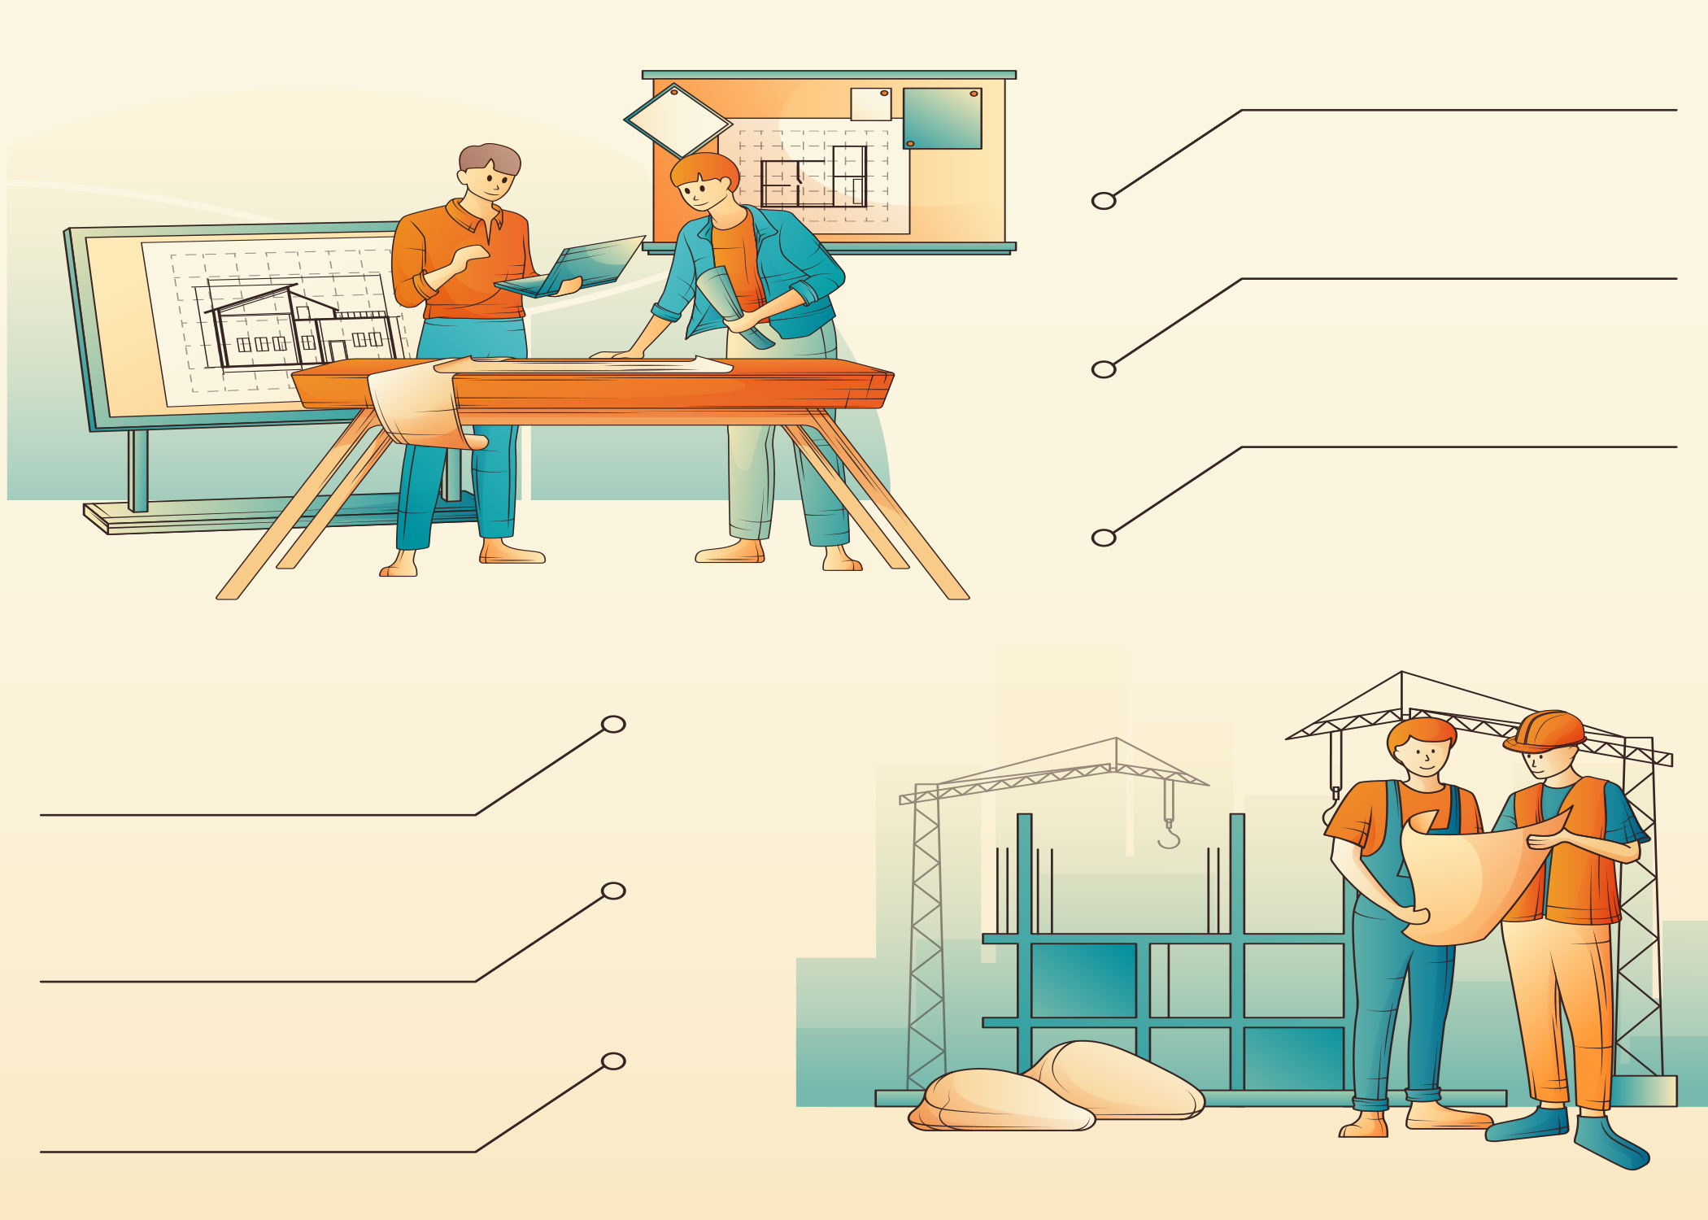
Projects with embedded sustainability parameters, registered under GRIHA rating.
Participants must submit the prescribed presentation template provided with the guidelines.
The presentation should explain project strategies as instructed, supported by photographs, and cover all applicable award categories in a single submission.
Connect on our social media handles for updates
Submit entries to ep.awards@grihaindia.org by 10 September 2026.
Winners will be felicitated at the 18th GRIHA Summit on
3rd – 4th November 2026.
Project team may mention their ongoing or completed interventions
Submit entries to ep.awards@grihaindia.org by 10 September 2026.
Connect on our social media handles for updates

Project Brief
Enter here….
Enter here….

Enter here….

Enter here….

(Please provide Image in JPG format)
Site area (sqm.)

Location

GRIHA project code

Name of the project
Project Brief
Built-up area (sqm.)

Enter here….

No. of building blocks

Enter here….

Name of building blocks (If blocks are >1)

Enter here….

No. of Storeys

Enter here….

Building typology

Enter here….

(Please provide Image in JPG format)
Project Explanation
Final score of the project will be evaluated as per the percentages mentioned below.
Energy Management –
The project team needs to demonstrate optimization of energy consumption through efficient lighting/ HVAC/ system designing
If the project team has an efficient operation and maintenance protocol which can optimize energy consumption of the project

Energy Demand and Supply –
  - List the strategies opted in the project to reduce the energy consumption
  - SHGC of glass
  - WWR and SRR of project
  - Brief about HVAC system installed
  - Specifications of HVAC system installed
  - Others
  - Type of internal and external lighting fixtures installed
  - ECBC compliance report
  - Efficiency of motors and pumps installed
  - Operation and maintenance
  - O&M policy
  - Training for maintenance
  - Contract for O&M
  - List of maintenance team
  - List of energy meters such as HVAC, RE, external lighting, common area, etc. installed in the project.
  - Reduction of energy consumption (%)
  - Benchmark EPI: ……….KWh/ m²/year
  - Proposed EPI: ………KWh/ m²/year

Project Explanation
Final score of the project will be evaluated as per the percentages mentioned below.
Passive Architecture Design –
- List the strategies opted in the project
- Impact analysis (simulations, calculations, etc.)
Passive Architecture Design –
The project team needs to demonstrate the strategies in which natural site features (topographical/microclimatic) can be protected and incorporated into the project design.

Project Explanation
Final score of the project will be evaluated as per the percentages mentioned below.
Renewable Energy Utilization –
The project team needs to demonstrate the renewable energy generation on site (towards net zero/ net positive energy approach)

Renewable Energy Utilization (solar PV, solar hot water, wind, biomass etc.) –
- Overall energy consumption of internal artificial lighting and space conditioning
- Percentage of renewable energy system to offset the energy consumption for internal artificial lighting and space conditioning
- Rated capacity of renewable energy system installed in the project
Project Explanation
Final score of the project will be evaluated as per the percentages mentioned below.
Sustainable Building Materials /Technologies –
The project team needs to demonstrate the use of locally available materials and material with high recycle content (like fly-ash or any other BIS recommended waste)
If the project is using any innovative technologies and materials to reduce carbon footprint in the project.

Sustainable Building Materials /Technologies –
  - List the materials/technologies used in the project
    - Structural application
    - Materials used in wall
    - Materials used in roof
    - Interior finishes
    - Exterior finishes
  - *Basis carbon estimation (copy of BOQ and carbon calculation sheet)
  - Prepare an inventory specifying the distances for sources the raw material to the site on geographical map.

Project Explanation
Final score of the project will be evaluated as per the percentages mentioned below.
Integrated Water Management –
  - Briefly describe the water management strategies to reduce building and landscape water consumption.
  - Reduction in landscape water consumption & Reduction in building water consumption (%)
  - Water Performance Index (WPI) of the project
  - Mention the flow rate of plumbing system installed in the project
  - List of native and exotic species planted on site along with the irrigation system installed in the project.
  - Water used for various purposes meets the Bureau of Indian Standards.
  - Type and capacity of STP installed in the project
  - Briefly describe the treatment and segregation of wastewater (into grey water and black water) separately in the project
  - Recycling and reusing treated wastewater in the project.
  - Provision of rainwater harvesting pits and rainwater storage in the project.

Integrated Water Management –
The project team needs to demonstrate the water saving, recycling and reuse on site (towards net zero/ net positive approach)
If the project is implementing any innovative storm water management scheme
Project Explanation
Final score of the project will be evaluated as per the percentages mentioned below.
Site Management (During Construction) –
The project team needs to demonstrate the best site management practices during construction
Site Management (During Construction) –
  - List of key features of best site management practices opted during construction along with photographs.
  - Strategies to reduce potable water during construction phase.
  - Site logistic plan of the project.
Project Explanation
Final score of the project will be evaluated as per the percentages mentioned below.
Construction Workers Health and Safety (During Construction) –
  - List of key features of the initiatives taken for construction workers working in the project along with photographs.
  - Provision of creche facility, grocery shop provided on site/at labour accommodation.
Construction Workers Health and Safety (During Construction) –
The project team needs to demonstrate the safe, healthy and hygienic working & living conditions for construction workers working in the project.

Name | Designation | Organization | Mobile no. | Email id
Contact Details

